**Social Capital and Voting Behaviour in the United States**

Pedro Fierro1*, Andrés Rodríguez-Pose2, Francisco Rowe3 and Ellen Helsper4

1 Business School, Adolfo Ibanez University, Viña del Mar, Chile.

2 Department of Geography and Environment, London School of Economics and Political Science, London, United Kingdom.

3 Geographic Data Science Lab, University of Liverpool, Liverpool, United Kingdom

4 Department of Media and Communication, London School of Economics and Political Science, London, United Kingdom.

* Corresponding Author: Business School, Adolfo Ibanez University, Padre Hurtado 750, Viña del Mar 25200000, Chile. pedro.fierro@uai.cl. ORCID: https://orcid.org/0000-0002-8910-9461

**Acknowledgments:** This work was supported by FONDECYT project # 1231927 and the ANID-Millennium Science Initiative Program # NCS 2021_063

**Social Capital and Voting Behaviour in the United States**

**Abstract**

Social capital has traditionally been viewed as a fundamental driver of democratic vitality. However, since the late-20th century, it has been suggested that social capital may also have adverse effects, potentially fostering totalitarian and populist ideologies. This paper examines the political implications of two different types of social capital —bonding social capital and bridging social capital—, using the 2016 and 2020 U.S. presidential elections as a case study. By examining at the county level, we find that the impact of social capital on antisystem voting behaviour is contingent upon the type of social capital involved. Bonding social capital, characterised by close-knit, homogeneous networks, is positively correlated with antisystem behaviours, as proxied by the additional electoral support for Donald Trump. In contrast, bridging social capital, which involves connections across diverse social groups, shows a negative correlation. Furthermore, our analysis reveals a complex interaction between economic and demographic changes, social integration, and political tendencies in a period of economic transition. These findings underscore the multifaceted nature of social capital and its critical role in understanding its origins and effects.

**Keywords:** Social capital; geography of discontent; anti-establishment; territorial inequalities

1. **INTRODUCTION**

Social capital has long been recognised as a crucial element in assessing the health and vitality of democratic systems and society at large. In recent years, concerns have grown over the health of democracy as voters across the democratic world increasingly turn to populist and/or anti-options. In electoral terms, social capital has been viewed as a catalyst for political engagement and voting behaviours, primarily through its influence on civic participation and trust (Coleman, 1988; Putnam, 1995, 2000). Yet, although social capital is typically seen as a positive counterforce against populist movements, some studies have highlighted its dual nature, suggesting that under certain conditions, high levels of social capital might foster anti-establishment sentiments (Fitzgerald & Lawrence, 2011; Rodríguez-Pose et al., 2021), and could be at the centre of the rise of the populist wave gripping many Western countries.

Foundational studies of social capital reveal that the concept extends beyond a single dimension, comprising a variety of indicators that impact different aspects of social capital. This research adopts the well-known distinction between bonding and bridging social capital, hypothesising that each type of social capital has distinct effects on voting preferences of individuals. The aim is to explore the roles of different forms of social capital in either reinforcing or undermining electoral support for anti-establishment narratives in specific settings.

Drawing on data from the META database and employing the methodologies recently developed by Chetty et al. (Chetty et al., 2022a, 2022b), we conceptualise social capital across three dimensions: a) social connectedness, which gauges interactions among individuals from diverse socioeconomic backgrounds; b) social cohesion, which is characterised by clusters of friendships and social networks; and c) civic engagement, which is denoted by volunteering rates and the presence of civic organisations within a community. Social cohesion and civic engagement are indicative of bonding social capital, strengthening networks within homogeneous communities. Conversely, social connectedness represents bridging social capital, characterised by diversity and interactions between different communities.

Recent research suggests that the rise of antisystem narratives can often be traced back to persistent economic and demographic decline in areas with high levels of social capital (e.g. Rodríguez-Pose et al., 2024). We, however, posit that, although economic decline is a crucial driver of electoral support for more extreme options, this electoral support is fundamentally mediated by the relevance and type of social capital prevalent in each territory. Support for more extreme political options will differ depending on the specific type of social capital in question. Using Donald Trump’s electoral performance in the 2016 and 2020 presidential elections as a case study, the findings of the analysis validate the hypotheses: bonding social capital is positively associated with Trump’s vote margins —serving as a proxy for the rise of antisystem behaviours in the US— whereas the presence of bridging social capital shows a negative correlation with additional support for Donald Trump. Thus, it is not all dimensions of social capital that predispose a community to antisystem political action, but rather the presence of local, homogeneous networks.

The article proceeds as follows: first, we examine the relationship between social capital and antisystem stances, followed by a discussion on the multidimensional nature of social capital. The methodology section then elaborates on the data and measures employed, outlining the analytical strategy adopted. Subsequently, we present and discuss the results of the empirical analysis, culminating in a conclusion that considers future research avenues and acknowledges the study's limitations.

Through this research, we explore the complex interplay between social capital, territorial disparities, and support for antisystem narratives. By distinguishing between bonding and bridging connections, our aim is to unravel the influence of social capital on political dynamics across diverse territories.

1. **EXPLORING THE ROLE OF SOCIAL CAPITAL IN ANTISYSTEM NARRATIVES AND TERRITORIAL DISPARITIES** 
   1. **The Conceptual Evolution of Social Capital**

The concept of social capital has been analysed using a variety of lenses, each contributing to a broader understanding of the term (Portes, 1998). This initial review focuses on three key perspectives: a) social capital as personal resources linked to class; b) as a community resource associated with trust; and c) as a network of resources related to the circulation of information and behaviours.

Originally, Bourdieu coined the term social capital to describe the strong, durable relationships that provide individuals access to resources beyond their immediate reach. For Bourdieu, this concept was intricately linked to class structures, presenting a somewhat critical view of social capital. He suggested that social capital serves as a mechanism for perpetuating class hierarchies, with resource-rich networks concentrated among elites who establish and maintain institutions to preserve their advantages over time. According to Bourdieu, social capital is “the sum of the resources, actual or virtual, that accrue to an individual or a group by virtue of possessing a durable network of more or less institutionalised relationships of mutual acquaintance and recognition” (Bourdieu & Wacquant, 1992, p. 119). These are formal networks of strong ties among individuals with similar characteristics that confer a certain status or class, often referred to as “friending bias” in recent studies (e.g. Chetty et al., 2022b). Such networks do more than provide access to material resources that can enhance one’s economic capital. They also offer symbolic resources that enrich cultural capital, including socialisation into specific norms, values, and behaviours characteristic of a particular group. Bourdieu thus sees social capital as resources emerging from social structure, “made up of social obligations ('connections’), which is convertible, in certain conditions, into economic capital and may be institutionalised in the form of a title” (Bourdieu, 1986, p. 243).

In contrast, Putnam interpreted social capital more positively as a community resource vital for societal health. He defined social capital as “features of social organisation such as networks, norms, and social trust that facilitate coordination and cooperation for mutual benefit” (Putnam, 1995, p. 67). This form of social capital is grounded in public and accessible social networks, often measured by engagement in community and civic organisations. These networks connect people from diverse backgrounds and do not require intense, continuous interaction among members. Putnam argued that individuals could benefit from this form of social capital without active participation in community activities. He candidly admitted, “My wife and I have the good fortune to live in a neighbourhood of Cambridge, Massachusetts, that has a good deal of social capital: barbecues and cocktail parties and so on. I am able to be in Uppsala, Sweden, confident that my home is being protected by all that social capital, even though —and this is the moment for confession— I actually never go to the barbecues and cocktail parties” (Putnam, 2000, p. 138). These interactions foster trust and cooperation within broader society. According to the “bowling alone” hypothesis, the decline in membership and participation in community activities has had pernicious consequences, leading to increased individualism, alienation, and diminished solidarity and trust in public institutions (Putnam, 2002). Social capital in Putnam’s view is a local phenomenon with far-reaching positive societal implications, closely linked to civic participation and commonly measured through activities such as volunteering, church attendance, and voting.

Coleman (1988) and later Lin (2008) offer a different perspective, conceptualising social capital as a network resource that can be analysed and measured coherently. Lin (2008) defined social capital as access to resources through network ties, which are organically rather than formally organised. This perspective marks a shift from institutionalised networks to individual, informal networks not necessarily tied to local organisations or institutions. The advent of digital technologies has led many scholars to argue for the emergence of a network society, with Manuel Castells famously asserting that technology has generated connections between people and institutions previously unable to interact: “All networks exist, but the connection between everything and everything—be it financial markets, politics, culture, media, communications, etc - that's new because of the new digital technologies" (BBC, 2012). Network society theories adopt a more optimistic view of open technological networks as platforms for expanding social capital by creating bridges between otherwise disconnected individuals.

This perspective differs from Wellman et al.'s (2001, 2003) concept of networked individualism. They argue that too much of the analysis of online life occurs in isolation from other aspects of daily life. In their view, community ties have rarely been local, even before the internet era. A longstanding trend has been the shift towards "networked individualism", where the individual, rather than the household or work unit, is the primary operator of a network. Research following this approach suggests that heavy internet users tend to have more friends than others, resulting in higher levels of social capital, both offline and online, through broad, loose networks of people with shared interests. Whether this "rich-get-richer" phenomenon manifests depends on the characteristics of the network’s structure and the individual’s position within it (Kadushin, 2012).

These discussions require, however, a distinction between the type of social capital generated and used. Different researchers have proposed different types of social capital. Putnam (2000) made the distinction between bonding and bridging social capital, two concepts often conflated, but distinct from Granovetter’s (1973) weak and strong ties. Bonding social capital exists within a specific, relatively homogenous, group or community, while bridging social capital connects different social groups, classes, races, religions, or other significant sociodemographic or socioeconomic categories (Chetty et al., 2022a, 2022b; Claridge, 2018). Bonding capital links individuals who are similar, reinforcing existing bonds and creating cohesion within established networks. Conversely, bridging capital involves connections with people of different backgrounds and resources, enabling access to new resources, behaviours, norms, and values that may not be available within one’s immediate circle (Gittell & Vidal, 1998).

* 1. **Spatial inequality, social capital and antisystem narratives.**

The rise of antisystem narratives —including different forms of populism, nationalism, Euroscepticism, and supremacism— poses significant challenges to liberal democracies worldwide. Recent studies suggest that these phenomena are shaped not only by individual factors but also by territorial context and spatial elements (Dijkstra et al., 2020; Koeppen et al., 2021; Lenzi & Perucca, 2021). Certain regions, seemingly overlooked or marginalised, harbour citizens who experience feelings of powerlessness and neglect (Fierro, Aravena-Gonzalez, et al., 2024), creating a fertile ground for anti-establishment movements (Rodríguez-Pose, 2018, 2020). Whether through deindustrialisation in the United States (McQuarrie, 2017) or recent trajectories of decline and stagnation in Europe (Diemer et al., 2022; Rodríguez-Pose et al., 2024), the evidence invites a re-examination of the role economic factors play in the emergence and success of illiberal projects.

In this context, territorial factors contributing to the success of illiberal or anti-establishment narratives have been studied across various settings. This is the case, for instance, the rise of far-right support in neglected Austrian neighbourhoods (Essletzbichler & Forcher, 2022), the success of Brexit in England (Alabrese et al., 2019; Goodwin & Heath, 2016; Jennings & Stoker, 2019), the north-south divide and the rise of populism in Italy (Faggian et al., 2021; Urso et al., 2023), or the centre-periphery cleavage and radical right support in Germany (Ziblatt et al., 2023), among others.

These spatial elements influence more than just voting behaviour. Recent research suggests that being born in a region with high unemployment can have long-lasting effects on individuals' electoral inclinations, policy preferences, and political values (McNeil et al., 2023). Spatial conditions and, in particular, territorial marginalisation also have a considerable impact on civic engagement (Fierro, Rivera, et al., 2024) and are deemed to drive the rise of ‘green discontent’ (Rodríguez-Pose & Bartalucci, 2023).

The impact of these territorial conditions —such as economic decline and demographic changes— on electoral preferences may also be connected to the levels of social capital in specific areas (Rodríguez-Pose et al., 2021). The relationship between social interactions and illiberal narratives has been studied in various contexts. For example, some scholars have suggested that the rise of Nazism was partly driven by social cohesion, which positively influenced the rise of Hitler in Germany in the 1930s (Allen, 1965; Childers, 1984). More recently, Fitzgerald and Lawrence (2011) have identified changing community dynamics as an understudied factor contributing to anti-elitist and anti-establishment sentiments. In their analysis of Switzerland, they conclude that social cohesion uniquely explains support for the radical right Swiss People’s Party. In the United States, Rodríguez-Pose et al. (2021) show that counties with a stronger social capital were more likely to support Donald Trump in the 2016 and 2020 elections, particularly when considering recent economic decline.

The explanations for these findings are varied. Over the past few decades, it has been argued that in response to modern challenges and the deterioration of traditional community bonds, individuals have sought refuge in groups with strong local identities that offer a sense of belonging in a globalised world (Barber, 1996; Gordon, 2018). In the UK, for instance, some authors have suggested that the success of Brexit in certain areas can be partly explained by specific personality traits. Psychological openness is the trait that matters most when explaining Brexit preferences in some districts (Garretsen et al., 2018). In terms of territorial context and social cohesion in the US, Cramer (2012, 2016) has shown that ‘group consciousness’ may affect electoral preferences, evoking a ‘rural consciousness’ among people living in marginalised rural areas. This consciousness is anchored in the perception that urban elites are distant and disdainful of rural lifestyles. According to Cramer, there is a sense of in-group pride which can be associated with social cohesion, contrasting with feelings of relative deprivation.

However, it is essential to acknowledge that social capital, as previously discussed, is not a one-dimensional concept. The tendency to view social capital as a single construct stems from practical limitations, particularly the scarcity of detailed data at the county level. Recently, scholars have introduced a method for measuring distinct dimensions of social capital, including economic connectedness, social cohesion, and civic engagement (Chetty et al., 2022a, 2022b), which align with the previous distinction between bonding and bridging interactions.

On the one hand, Chetty et al. (2022a) show that economic connectedness, defined as ‘cross-class interactions’ or bridging capital, is the most crucial factor in explaining economic mobility. Similarly, Muringani et al. (2021) find that bridging social capital is a fundamental driver of economic growth across regions of Europe. This type of network capital relates to Coleman and Lin's sense of network capital. On the other hand, social cohesiveness relates to the extent of homogeneity within the network and the level of interconnectedness among friends. For Fitzgerald and Lawrence (2011), social cohesion can be understood as the interconnectedness of members within a group, measured through commuting, linguistic homogeneity, and home ownership. This type of bonding capital, while not explicitly but conceptually linked to Bourdieu’s understanding of social capital, is distinct from civic engagement social capital, which is more closely aligned with Putnam’s definition and involves a broader community bond beyond close personal networks. Generally, the impact of bonding social capital on economic and social outcomes tends to be viewed with greater caution. Muringani et al. (2021), for example, report that it leads to far lower economic growth than bridging social capital.

Therefore, understanding the link between different types of social capital and economic and political outcomes presents a complex challenge. Considering previous findings, it is plausible to argue that our main variable of interest, antisystem voting behaviour, might be more closely related to bonding social capital —such as social cohesion or civic engagement— than to bridging social capital —such as economic connectedness. In other words, dimensions linked to homophily may exhibit a positive correlation with anti-establishment perspectives, whereas dimensions associated with heterophily, signifying diversity, may demonstrate a negative relationship with electoral support for anti-establishment projects.

Based on the above discussion, we seek to investigate the intricate interplay between social capital and antisystem voting behaviour by testing the following hypotheses:

**H1:** Voters in counties with higher social cohesion (bonding social capital) have been more likely to exhibit anti-system behaviours, as proxied by the additional support for Donald Trump in the 2016 and 2020 US elections.

**H2:** Voters in counties with higher civic engagement (bonding social capital) have been more likely to exhibit anti-system behaviours, as proxied by the additional support for Donald Trump in the 2016 and 2020 US elections.

**H3:** Voters in counties with higher economic connectedness (bridging social capital) have been less likely to exhibit antisystem behaviours, as proxied by the additional support for Donald Trump in the 2016 and 2020 US elections.

Additionally, we aim to investigate how these relationships have been shaped by territorial disparities and socio-economic changes in the U.S. over recent decades, particularly given evidence that varying territorial trajectories can influence political discontent. Therefore, we will explore the following research question:

**RQ1:** How do demographic change and economic decline at the county level influence the relationship between social capital and antisystem behaviours?

By testing these hypotheses and examining the latter research question, we aim to contribute to a better understanding of the spatial roots of the rise of anti-establishment politics.

1. **METHODS**
   1. **Data Sources**

The data for this study were obtained from various sources, specified in the description of each variable. The database used in this work is public, allowing the analyses and results to be replicated.

* 1. **Key Measures**
     1. ***Antisystem voting behaviour (Trump’s Vote Margin)***

Anti-system voting behaviour is measured by the additional support for Donald Trump in the 2016 and 2020 US presidential elections. This measure, termed the 'Trump margin', represents the difference in voter support for Donald Trump compared to the previous Republican candidate, Mitt Romney. This variable has been utilised in previous studies (Rodríguez-Pose et al., 2021). To construct it, we used data from the MIT Election Data and Science Lab.

**Figure 1.** US Presidential Elections 2016 and 2020 (county level)

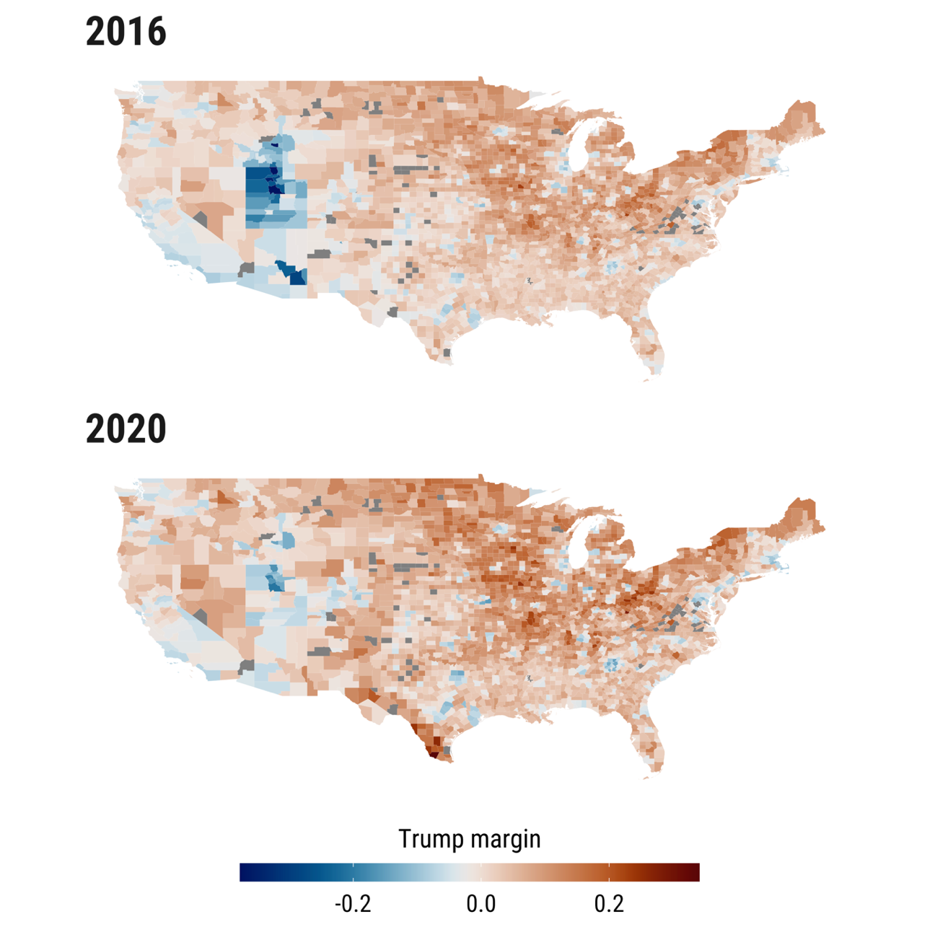

Source: Own Elaboration, based on Rodriguez-Pose et al 2021.

**Figure 2.** Histograms of US Presidential Elections 2016 and 2020 (county level)

Source: Own Elaboration.

* + 1. ***Comprehensive social capital***

For the comprehensive measurement of social capital, this study adopts the framework proposed by Rupasingha et al. (2006). We specifically resort to its subsequent refinement by Penn State researchers in 2014. This framework is grounded in the seminal work of Putnam (1993, 2000) and encompasses four primary components:

(a) the count of non-profit organisations within a county, applicable solely at the national level;

(b) the census response rate in 2010;

(c) voter participation in the 2012 presidential elections; and

(d) the tally of associational indicators.

Each of these components is standardised, aggregated, and normalised by the population size. The initial principal component derived from these factors serves as the index of social capital, providing a consolidated measure reflective of the multifaceted nature of social capital within the specified geographic scope. This approach facilitates a nuanced understanding of social capital's influence and distribution, aligning with the broader objective of assessing its impact on various societal outcomes.

* + 1. ***Social capital dimensions:***

Following the work of Chetty et al. (2022a, 2022b) and the Opportunity Insights Project, where social capital was measured using different dimensions based on individual data from META, using 21 billion Facebook friendships. It is important to highlight that in that project, the authors used these META data as a proxy for real-world friendship relationships rather than online interactions per se. Consequently, they argue that this data is reasonably representative of the national population at that time, in terms of sex, age, and language. Additionally, they emphasise the strong coverage in both national and local contexts, which is essential for analysing differences between counties. Thus, based on the contributions of the Opportunity Insight Project, we distinguish between three dimensions of social capital: civic engagement, social cohesion, and economic connectedness.

1. ***Civic Engagement:*** Civic engagement is analysed through two variables provided by the Opportunity Insights Project: civic organisations and volunteering rate. i) Civic organisations measure the number of Facebook Pages predicted to be ‘public good’ pages, based on page title, category, and other page characteristics, per 1,000 users in the county. ii) The volunteering rate measures the percentage of Facebook users who are members of a group predicted to be about 'volunteering' or 'activism', based on group title and other group characteristics.

**Figure 2** Civic Engagement Dimension

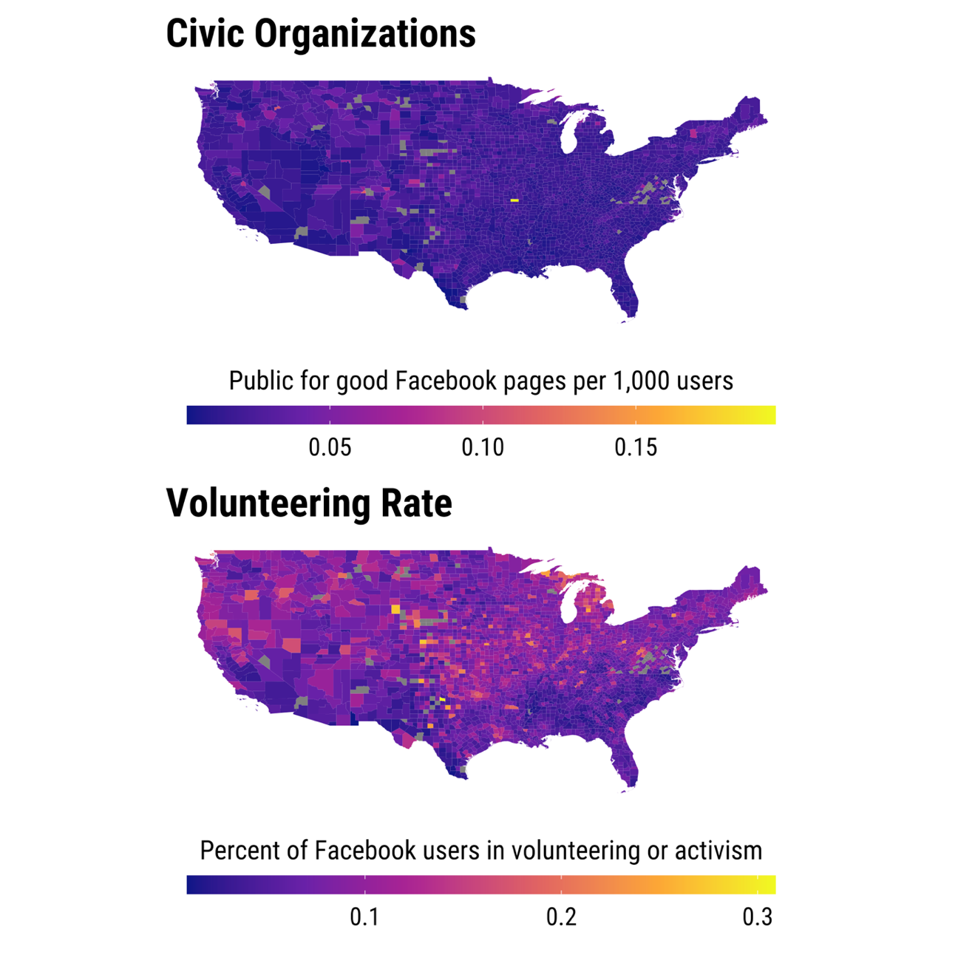

Source: Own elaboration with data collected from socialcapital.org (Chetty, 2022a; 2022b). See the text for details on the metrics used.

1. **Social Cohesion:** Social cohesion is analysed through two specific variables provided by the Opportunity Insights Project: social network and friendship clustering. i) Social networks measure the proportion of within-county friendships where the pair of friends share a third mutual friend within the same county. ii) Friendship clustering measures the average fraction of an individual’s friend pairs who are also friends with each other.

**Figure 3** Social Cohesion Dimension

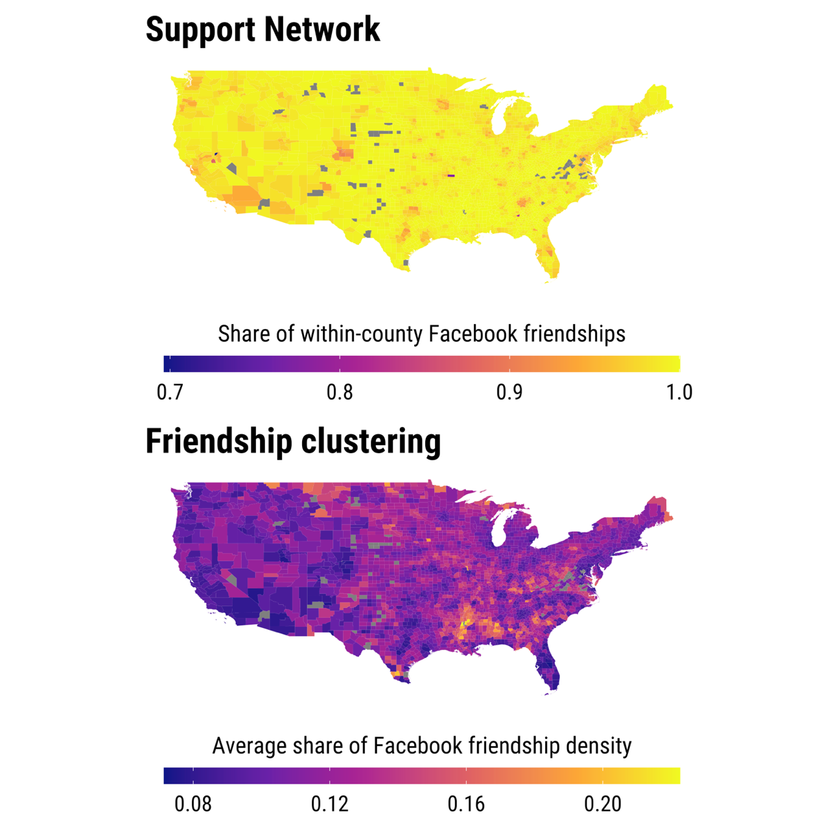

Source: Own elaboration with data collected from socialcapital.org (Chetty, 2022a; 2022b)

1. **Economic Connectedness:** Economic connectedness is analysed using a variable provided by the Opportunity Insights Project, defined as twice the share of high-SES (Socioeconomic Status) friends among low-SES individuals, averaged over all low-SES individuals in the county.

**Figure 4** Economic Connectedness Dimension

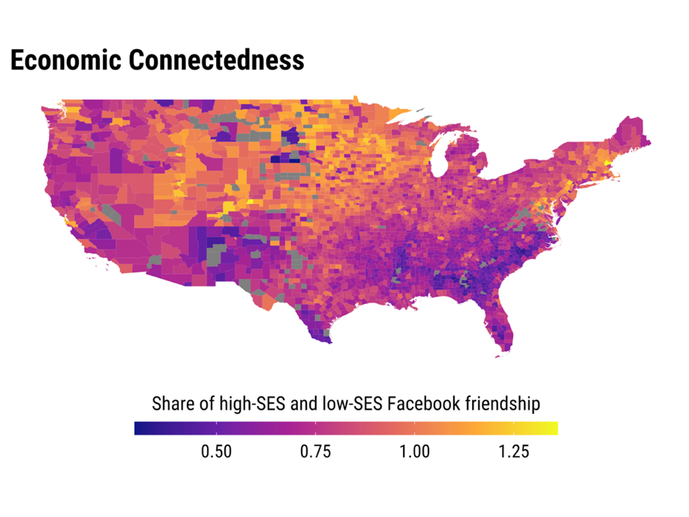

Source: Own elaboration with data collected from socialcapital.org (Chetty, 2022a; 2022b)

As discussed in the theoretical framework, civic engagement and social cohesion are types of bonding social capital, whereas social connectedness is a type of bridging social capital.

* + 1. ***Demographic and economic change:***

Various variables for 2016 have been included in the analysis to capture the current socioeconomic status and measure economic decline over time. Specifically, the analyses include income per capita for 2016, inequality measured by the Gini index for 2016, the unemployment rate for 2016, population density for 2016, and employment change between 1980 and 2016.

* + 1. ***Control variables:***

To ensure the robustness of the model, we control for other sociodemographic variables typically linked to electoral turnout in the US, including the education level for 2016, the share of the black population for 2016, sex ratio (males) for 2016, and age dependency (young) for 2016. Figure 5 presents the correlation matrix for all the variables included in the models.

**Figure 5** Correlation matrix (Pearson)

Source: Own Elaboration

1. **RESULTS**

Initially, a first model was estimated based on Rodríguez-Pose et al. (2021). This model aims to identify and confirm the positive relationship between the comprehensive measure of social capital and the propensity to support Donald Trump (compared to the previous republican candidate) at the ballot box in a particular US county. Figure 6 illustrates this relationship, highlighting the coefficient of social capital in relation to the Trump margin. Additionally, the comprehensive regression analysis is detailed in Appendix 1 and 2. Both appendices account for fixed state effects, ensuring the robustness of the findings.

**Figure 6** OLS regression for Trump’s margin votes for 2016 and 2020, using a comprehensive measurement of Social Capital

Note: This plot displays estimates for our comprehensive measure of social capital. The full regression model estimates incorporate a range of control variables, including indicators of socioeconomic decline. The full set of results are presented in Appendix 1 and 2.

However, the focus of this study is to test whether these results for overall social capital, confirmed by the literature since the late-20th century, are consistent across all dimensions of social capital or if there are significant variations depending on the specific dimension. The models presented in Table 1 and Table 2 aim to contrast this notion. All variables used to measure social capital are significantly related to the propensity to vote for Donald Trump beyond the traditional support for the Republican Party, yet they do so differently.

For the **civic engagement dimension** —measured through the presence of civic organisations and volunteer rates— the relationship is positive, closely mirroring our comprehensive measure of social capital. A similar pattern is observed with the **social cohesion dimension** —measured through friendship clustering and support networks— where the relationship is also positive. However, a stark contrast emerges when examining **economic connectedness**. Here, the relationship is negative, indicating that higher levels of bridging social capital (connections between communities) are associated with a reduced support for Donald Trump in both 2016 and 2020 presidential elections. This finding aligns with our initial hypothesis: bonding social capital (relations within a community) tends to bolster antisystem behaviours, whereas bridging social capital (relations between communities) appears to mitigate them.

**Figure 7** Regression estimates for Trump Margin in 2016 and 2020, with different measures of social capital

Note: The full regression estimates are presented in Apendix xxx and they include state fixed effects.

**Table 1** Basic Model (OLS estimation) for Trump Margin in 2016, with different measures of social capital

|  |  |  |  |  |  |
| --- | --- | --- | --- | --- | --- |
|  | Civic engagement | | Social cohesion | | Ec. Connected. |
|  | Organ. | Volunt. | Clusters | Sup. Net. | Soc. Con. |
| Income per capita (2016) | -0.000*** | -0.000*** | -0.000*** | -0.65*** | -0.000*** |
|  | (0.000) | (0.000) | (0.000) | (0.000) | (0.000) |
| Inequality (Gini 2016) | -0.026 | -0.018 | -0.076** | -0.065** | -0.064** |
|  | (0.024) | (0.024) | (0.023) | (0.024) | (0.025) |
| Employment change (1980-2016) | -0.856*** | -0.816*** | -0.817*** | -0.45*** | -0.739*** |
|  | (0.135) | (0.135) | (0.127) | (0.134) | (0.133) |
| Social Capital Community | 0.421*** | 0.117*** | 0.802*** | 0.709*** | -0.096*** |
|  | (0.08) | (0.024) | (0.041) | (0.051) | (0.008) |
| Density (2016) | -0.000* | -0.000** | 0.000 | 0.000 | -0.000* |
|  | (0.000) | (0.000) | (0.000) | (0.000) | (0.000) |
| Unemployment rate (2016) | 0.001* | 0.001* | 0.002** | 0.002*** | -0.000 |
|  | (0.001) | (0.001) | (0.001) | (0.001) | (0.001) |
| Education (2016) | 0.002*** | 0.002*** | 0.001*** | 0.002*** | 0.001*** |
|  | (0.000) | (0.000) | (0.000) | (0.000) | (0.000) |
| Share of black population (2016) | -0.000*** | -0.000** | -0.001*** | -0.000*** | -0.000*** |
|  | (0.000) | (0.000) | (0.000) | (0.000) | (0.000) |
| Sex ratio, males (2016) | 0.000 | 0.000 | 0.000 | 0.000 | 0.000 |
|  | (0.000) | (0.000) | (0.000) | (0.000) | (0.000) |
| Age dependency, young (2016) | -0.001*** | -0.001*** | -0.001*** | -0.001*** | -0.002*** |
|  | (0.000) | (0.000) | (0.000) | (0.000) | (0.000) |
| Share Married (2016) | 0.001*** | 0.002*** | 0.001*** | 0.001*** | 0.002*** |
|  | (0.000) | (0.000) | (0.000) | (0.000) | (0.000) |
| State FE | YES | YES | YES | YES | YES |

Note: Std. err. In (). p-value < ,1 †; p-value < 0,05 *; p-value < 0,005 **; p-value < 0,001 ***.

**Table 2** Basic Model (OLS estimation) for Trump Margin in 2020, with different measures of social capital.

|  |  |  |  |  |  |
| --- | --- | --- | --- | --- | --- |
|  | Civic engagement | | Social Cohesion | | Ec. Connected. |
|  | Organ. | Volunt. | Clusters | Sup. Net. | Soc. Con. |
| Income per capita (2016) | -0.000*** | -0.000*** | -0.000*** | -0.000*** | -0.000*** |
|  | (0.000) | (0.000) | (0.000) | (0.000) | (0.000) |
| Inequality (Gini 2016) | -0.011 | -0.005 | -0.087** | -0.066* | -0.028 |
|  | (0.029) | (0.029) | (0.027) | (0.029) | (0.031) |
| Employment change (1980-2016) | -0.803*** | -0.766*** | -0.765*** | -0.292† | -0.736*** |
|  | (0.163) | (0.163) | (0.15) | (0.16) | (0.164) |
| Social Capital Community | 0.382*** | 0.115*** | 1.115*** | 0.916*** | -0.061*** |
|  | (0.097) | (0.029) | (0.048) | (0.061) | (0.01) |
| Density (2016) | 0.000 | 0.000 | 0.000*** | 0.000*** | 0.000 |
|  | (0.000) | (0.000) | (0.000) | (0.000) | (0.000) |
| Unemployment rate (2016) | 0.001 | 0.001 | 0.001* | 0.002* | 0.000 |
|  | (0.001) | (0.001) | (0.001) | (0.001) | (0.001) |
| Education (2016) | 0.004*** | 0.004*** | 0.002*** | 0.003*** | 0.003*** |
|  | (0.000) | (0.000) | (0.000) | (0.000) | (0.000) |
| Share of black population (2016) | -0.000*** | -0.000*** | -0.001*** | -0.000*** | -0.001*** |
|  | (0.000) | (0.000) | (0.000) | (0.000) | (0.000) |
| Sex ratio, males (2016) | 0.000 | 0.000 | 0.000 | 0.000* | 0.000* |
|  | (0.000) | (0.000) | (0.000) | (0.000) | (0.000) |
| Age dependency, young (2016) | -0.001*** | -0.001*** | -0.001*** | -0.001*** | -0.002*** |
|  | (0.000) | (0.000) | (0.000) | (0.000) | (0.000) |
| Share Married (2016) | 0.002*** | 0.002*** | 0.001*** | 0.002*** | 0.002*** |
|  | (0.000) | (0.000) | (0.000) | (0.000) | (0.000) |
| State FE | YES | YES | YES | YES | YES |

Note: Std. err. In (). p-value < ,1 †; p-value < 0,05 *; p-value < 0,005 **; p-value < 0,001 ***.

Further analysis was conducted to explore interactions that may explain how these different dimensions of social capital relate to additional support for Donald Trump, particularly in the context of socio-economic changes or decline.

In the case of **bonding social capital** —represented by civic engagement or social cohesion— the model incorporating an interaction between social capital and population change yields statistically significant coefficient for social capital, with the coefficient changing sign (see Table 3).

For variables representing **social cohesion**, which also serve as indicators of bonding social capital, the results are remarkably consistent. Specifically, across all models examining support networks, a positive and significant relationship is observed between social cohesion and antisystem behaviours. Additionally, variables indicative of economic and demographic shifts —such as changes in employment, population, earnings, and wages— also display positive and significant coefficients. This indicates that regions experiencing more substantial changes tend to exhibit a higher propensity for antisystem behaviours.

However, the interaction between socioeconomic changes and support networks is negative and significant, highlighting that while each variable independently contributes to increased electoral support for Trump (compared to the previous republican candidate), their combined influence reduces this support. In contrast, findings from the friendship clustering regressions present a more complex picture. There remains a positive relationship between social capital, as captured by friendship clustering, and additional support for Trump, yet socioeconomic change is negatively associated with it. Nonetheless, the interaction between friendship clustering and socioeconomic changes is positive, indicating that the influence of friendship clustering on antisystem behaviours becomes more pronounced in regions undergoing socioeconomic changes. This implies that in contexts of economic flux, the cohesive force of friendship networks may magnify antisystem behaviours, highlighting the nuanced role of social cohesion amid shifting economic landscapes.

**Table 3.** Interactions between social capital and economic change, 2016 elections (Part 1).

|  |  |  |  |  |  |  |  |  |
| --- | --- | --- | --- | --- | --- | --- | --- | --- |
|  | **Civic Org.** | | | | **Volunt. Rate** | | | |
| Income per capita (2016) | -0.000*** | -0.000*** | -0.000*** | -0.000*** | -0.000*** | -0.000*** | -0.000*** | -0.000*** |
|  | (0.000) | (0.000) | (0.000) | (0.000) | (0.000) | (0.000) | (0.000) | (0.000) |
| Inequality (Gini 2016) | -0.026 | -0.118*** | -0.038 | -0.038 | -0.017 | -0.111*** | -0.031 | -0.03 |
|  | (0.024) | (0.023) | (0.024) | (0.024) | (0.024) | (0.023) | (0.024) | (0.024) |
| Social Capital | 0.27* | -0.054*** | 0.699* | 0.391 | 0.164*** | 0.076*** | 0.2* | 0.29† |
|  | (0.114) | (0.079) | (0.298) | (0.501) | (0.031) | (0.023) | (0.096) | (0.164) |
| Employment change 1980-2016 | -1.279*** |  |  |  | -0.16 |  |  |  |
|  | (0.266) |  |  |  | (0.316) |  |  |  |
| Population change 1980-2016 |  | -1.883 |  |  |  | -1.531*** |  |  |
|  |  | (0.133) |  |  |  | (0.156) |  |  |
| Average earnings per job change 1980-2016 |  |  | 0.313 |  |  |  | 0.292 |  |
|  |  |  | (0.203) |  |  |  | (0.213) |  |
| Average wages and salaries change 1980 2017 |  |  |  | -0.643* |  |  |  | -0.293 |
|  |  |  |  | (0.307) |  |  |  | (0.366) |
| Interactions |  |  |  |  |  |  |  |  |
| SC*Employment change | 22.099† |  |  |  | -8.865* |  |  |  |
|  | (11.946) |  |  |  | (3.863) |  |  |  |
| SC*Population change |  | 20.817*** |  |  |  | 0.651 |  |  |
|  |  | (6.106) |  |  |  | (1.895) |  |  |
| SC*Earnings change |  |  | -7.967 |  |  |  | -2.053 |  |
|  |  |  | (7.596) |  |  |  | (2.325) |  |
| SC*Wages change |  |  |  | 0.414 |  |  |  | -4.457 |
|  |  |  |  | (12.766) |  |  |  | (4.264) |
| Controls | YES | YES | YES | YES | YES | YES | YES | YES |
| State FE | YES | YES | YES | YES | YES | YES | YES | YES |

Note: Std. err. In (). p-value < ,1 †; p-value < 0,05 *; p-value < 0,005 **; p-value < 0,001 ***.

**Table 3.** Interactions between social capital and economic change, 2016 elections (Part 2)

|  |  |  |  |  |  |  |  |  |
| --- | --- | --- | --- | --- | --- | --- | --- | --- |
|  | **Support networks** | | | | **Friendship clustering** | | | |
| Income per capita (2016) | -0.000*** | -0.000*** | -0.000*** | -0.000*** | -0.000*** | -0.000*** | -0.000*** | -0.000*** |
|  | (0.000) | (0.000) | (0.000) | (0.000) | (0.000) | (0.000) | (0.000) | (0.000) |
| Inequality (Gini 2016) | -0.07** | -0.121*** | -0.078*** | -0.077** | -0.078*** | -0.127*** | -0.09*** | -0.089*** |
|  | (0.024) | (0.023) | (0.024) | (0.024) | (0.023) | (0.023) | (0.023) | (0.023) |
| Social Capital | 1.016*** | 0.504*** | 2.542*** | 3.085*** | 0.713*** | 0.504*** | 0.435* | 0.2 |
|  | (0.063) | (0.064) | (0.339) | (0.375) | (0.05) | (0.045) | (0.2) | (0.267) |
| Employment change 1980-2016 | 18.692*** |  |  |  | -2.781*** |  |  |  |
|  | (2.369) |  |  |  | (0.658) |  |  |  |
| Population change 1980-2016 |  | 6.621** |  |  |  | -1.916*** |  |  |
|  |  | (2.509) |  |  |  | (0.315) |  |  |
| Average earnings per job change 1980-2016 |  |  | 44.4*** |  |  |  | -1.113† |  |
|  |  |  | (8.247) |  |  |  | (0.623) |  |
| Average wages and salaries change 1980 2017 |  |  |  | 56.537*** |  |  |  | -2.413** |
|  |  |  |  | (8.98) |  |  |  | (0.834) |
| Interactions |  |  |  |  |  |  |  |  |
| SC*Employment change | -19.613*** |  |  |  | 17.372** |  |  |  |
|  | (2.424) |  |  |  | (5.711) |  |  |  |
| SC*Population change |  | -8.046** |  |  |  | 8.037** |  |  |
|  |  | (2.554) |  |  |  | (3.01) |  |  |
| SC*Earnings change |  |  | -44.58*** |  |  |  | 9.453† |  |
|  |  |  | (8.312) |  |  |  | (5.028) |  |
| SC*Wages change |  |  |  | -57.424*** |  |  |  | 15.644* |
|  |  |  |  | (9.075) |  |  |  | (6.873) |
| Controls | YES | YES | YES | YES | YES | YES | YES | YES |
| State FE | YES | YES | YES | YES | YES | YES | YES | YES |

Note: Std. err. In (). p-value < ,1 †; p-value < 0,05 *; p-value < 0,005 **; p-value < 0,001 ***.

**Table 3.** Interactions between social capital and economic change, 2016 elections (Part 3)

|  |  |  |  |  |
| --- | --- | --- | --- | --- |
|  | **Economic Connectedness** | | | |
| Income per capita (2016) | -0.000*** | -0.000*** | -0.000*** | -0.000*** |
|  | (0.000) | (0.000) | (0.000) | (0.000) |
| Inequality (Gini 2016) | -0.062* | -0.148*** | -0.086*** | -0.077** |
|  | (0.025) | (0.023) | (0.025) | (0.025) |
| Social Capital | -0.083*** | -0.076*** | -0.199*** | -0.186*** |
|  | (0.009) | (0.008) | (0.02) | (0.035) |
| Employment change 1980-2016 | 0.779 |  |  |  |
|  | (0.592) |  |  |  |
| Population change 1980-2016 |  | -0.511† |  |  |
|  |  | (0.298) |  |  |
| Average earnings per job change 1980-2016 |  |  | -1.616*** |  |
|  |  |  | (0.4) |  |
| Average wages and salaries change 1980 2017 |  |  |  | -2** |
|  |  |  |  | (0.701) |
| Interactions |  |  |  |  |
| SC*Employment change | -1.882** |  |  |  |
|  | (0.715) |  |  |  |
| SC*Population change |  | -1.038** |  |  |
|  |  | (0.332) |  |  |
| SC*Earnings change |  |  | 2.267*** |  |
|  |  |  | (0.439) |  |
| SC*Wages change |  |  |  | 2.219** |
|  |  |  |  | (0.857) |
| Controls | YES | YES | YES | YES |
| State FE | YES | YES | YES | YES |

Note: Std. err. In (). p-value < ,1 †; p-value < 0,05 *; p-value < 0,005 **; p-value < 0,001 ***.

The models examining the interaction between **economic connectedness** and socio-economic change variables at the county level show that, in every instance, the social capital variable —in this case, bridging social capital— exhibits a negative and significant association with the vote for Donald Trump in the 2016 and 2020 elections (see Tables 3 and 4). Nevertheless, the nature of these interactions varies. In cases related to earnings and job changes, as well as wages and salary alterations, the individual variables are negatively and significantly linked to additional support for Donald Trump, while their interaction with economic connectedness is positively and significantly correlated.

**Table 4.** Interactions between social capital and economic change, 2020 elections (Part 1)

|  |  |  |  |  |  |  |  |  |
| --- | --- | --- | --- | --- | --- | --- | --- | --- |
|  | Civic Org. | | | | Volunt. Rate | | | |
| Income per capita (2016) | -0.000*** | -0.000*** | -0.000*** | -0.000*** | -0.000*** | -0.000*** | -0.000*** | -0.000*** |
|  | (0.000) | (0.000) | (0.000) | (0.000) | (0.000) | (0.000) | (0.000) | (0.000) |
| Inequality (Gini 2016) | -0.011 | -0.1307*** | -0.023 | -0.025 | -0.001 | -0.13*** | -0.016 | -0.015 |
|  | (0.029) | (0.027) | (0.029) | (0.03) | (0.029) | (0.027) | (0.029) | (0.029) |
| Social Capital | 0.306* | -0.241** | 0.516 | -0.14 | 0.216*** | 0.057* | 0.273* | 0.544** |
|  | (0.138) | (0.093) | (0.359) | (0.604) | (0.038) | (0.026) | (0.115) | (0.198) |
| Employment change 1980-2016 | -1.017** |  |  |  | 0.652† |  |  |  |
|  | (0.321) |  |  |  | (0.380) |  |  |  |
| Population change 1980-2016 |  | -2.414*** |  |  |  | -1.996*** |  |  |
|  |  | (0.155) |  |  |  | (0.182) |  |  |
| Average earnings per job change 1980-2016 |  |  | 0.472† |  |  |  | 0.689** |  |
|  |  |  | (0.244) |  |  |  | (0.256) |  |
| Average wages and salaries change 1980 2017 |  |  |  | -0.416 |  |  |  | 0.697 |
|  |  |  |  | (0.371) |  |  |  | (0.441) |
| Interactions |  |  |  |  |  |  |  |  |
| SC*Employment change | 11.132 |  |  |  | -19.172*** |  |  |  |
|  | (14.436) |  |  |  | (4.653) |  |  |  |
| SC*Population change |  | 14.726* |  |  |  | -1.218 |  |  |
|  |  | (7.14) |  |  |  | (2.218) |  |  |
| SC*Earnings change |  |  | -4.148 |  |  |  | -3.949 |  |
|  |  |  | (9.139) |  |  |  | (2.795) |  |
| SC*Wages change |  |  |  | 12.989 |  |  |  | -11.203* |
|  |  |  |  | (15.412) |  |  |  | (5.143) |
| Controls | YES | YES | YES | YES | YES | YES | YES | YES |
| State FE | YES | YES | YES | YES | YES | YES | YES | YES |

Note: Std. err. In (). p-value < ,1 †; p-value < 0,05 *; p-value < 0,005 **; p-value < 0,001 ***.

**Table 4.** Interactions between social capital and economic change, 2020 elections (Part 2)

|  |  |  |  |  |  |  |  |  |
| --- | --- | --- | --- | --- | --- | --- | --- | --- |
|  | Support networks | | | | Friendship clustering | | | |
| Income per capita (2016) | -0.000*** | -0.000*** | -0.000*** | -0.000*** | -0.000*** | -0.000*** | -0.000*** | -0.000*** |
|  | (0.000) | (0.000) | (0.000) | (0.000) | (0.000) | (0.000) | (0.000) | (0.000) |
| Inequality (Gini 2016) | -0.072* | -0.141*** | -0.078** | -0.078** | -0.09** | -0.153*** | -0.099*** | -0.1*** |
|  | (0.028) | (0.027) | (0.028) | (0.028) | (0.027) | (0.026) | (0.027) | (0.027) |
| Social Capital | 1.285*** | 0.546*** | 3.305*** | 3.71*** | 0.976*** | 0.7*** | 0.818*** | 0.017 |
|  | (0.076) | (0.075) | (0.405) | (0.45) | (0.059) | (0.052) | (0.235) | (0.314) |
| Employment change 1980-2016 | 22.775*** |  |  |  | -3.835*** |  |  |  |
|  | (2.842) |  |  |  | (0.775) |  |  |  |
| Population change 1980-2016 |  | 6.701* |  |  |  | -3.02*** |  |  |
|  |  | (2.937) |  |  |  | (0.364) |  |  |
| Average earnings per job change 1980-2016 |  |  | 58.605*** |  |  |  | -0.666 |  |
|  |  |  | (9.853) |  |  |  | (0.732) |  |
| Average wages and salaries change 1980 2017 |  |  |  | 66.898*** |  |  |  | -3.461*** |
|  |  |  |  | (10.761) |  |  |  |  |
| Interactions |  |  |  |  |  |  |  |  |
| SC*Employment change | -23.635*** |  |  |  | 27.145*** |  |  |  |
|  | (2.907) |  |  |  | (6.727) |  |  |  |
| SC*Population change |  | -8.716** |  |  |  | 14.563*** |  |  |
|  |  | (2.99) |  |  |  | (3.483) |  |  |
| SC*Earnings change |  |  | -58.641*** |  |  |  | 7.515 |  |
|  |  |  | (9.93) |  |  |  | (5.911) |  |
| SC*Wages change |  |  |  | -67.313*** |  |  |  | 28.651*** |
|  |  |  |  | (10.875) |  |  |  | (8.091) |
| Controls | YES | YES | YES | YES | YES | YES | YES | YES |
| State FE | YES | YES | YES | YES | YES | YES | YES | YES |

Note: Std. err. In (). p-value < ,1 †; p-value < 0,05 *; p-value < 0,005 **; p-value < 0,001 ***.

**Table 4.** Interactions between social capital and economic change, 2020 elections (Part 3)

|  |  |  |  |  |
| --- | --- | --- | --- | --- |
|  | Economic Connectedness | | | |
| Income per capita (2016) | -0.000*** | -0.000*** | -0.000*** | -0.000*** |
|  | (0.000) | (0.000) | (0.000) | (0.000) |
| Inequality (Gini 2016) | -0.024 | -0.144*** | -0.052† | -0.042 |
|  | (0.03) | (0.028) | (0.03) | (0.031) |
| Social Capital | -0.04*** | -0.034*** | -0.167*** | -0.12** |
|  | (0.012) | (0.009) | (0.025) | (0.043) |
| Employment change 1980-2016 | 2.002** |  |  |  |
|  | (0.727) |  |  |  |
| Population change 1980-2016 |  | -1.251*** |  |  |
|  |  | (0.354) |  |  |
| Average earnings per job change 1980-2016 |  |  | -1.349** |  |
|  |  |  | (0.49) |  |
| Average wages and salaries change 1980 2017 |  |  |  | -0.924 |
|  |  |  |  | (0.862) |
| Interactions |  |  |  |  |
| SC*Employment change | -3.394*** |  |  |  |
|  | (0.878) |  |  |  |
| SC*Population change |  | -0.966* |  |  |
|  |  | (0.395) |  |  |
| SC*Earnings change |  |  | 2.239*** |  |
|  |  |  | (0.539) |  |
| SC*Wages change |  |  |  | 1.338 |
|  |  |  |  | (1.053) |
| Controls | YES | YES | YES | YES |
| State FE | YES | YES | YES | YES |

Note: Std. err. In (). p-value < ,1 †; p-value < 0,05 *; p-value < 0,005 **; p-value < 0,001 ***.

This suggests that in areas experiencing fluctuations in earnings and employment, the typically negative correlation between economic connectedness and additional support for Trump becomes less pronounced. Conversely, in scenarios involving employment and population changes, the interaction is negative. This suggests that in localities undergoing more substantial changes, the negative impact of social connectedness on antisystem behaviours is intensified. These results underscore the complexity of social capital’s influence on political behaviour, particularly in the context of economic and demographic shifts. They highlight the importance of considering the multidimensional nature of social capital when analysing its role in shaping electoral outcomes.

1. **Discussion and further research**

In recent years, a growing body of research has increasingly demonstrated that the rise of antisystem narratives —manifested in various forms such as populism, nationalism, and Euroscepticism— is deeply rooted in spatial factors. It has become evident that understanding the discontent and its democratic consequences requires a close examination of the specific contexts in which citizens live, particularly those neighbourhoods, cities, and regions that have been left behind by economic progress and social change.

Contributions from the fields of economic and political geography have prompted a re-evaluation of the factors influencing the rise of anti-system narratives and its transformation into votes for extreme and/or illiberal parties. Among these factors, social networks and interactions have gained significant prominence, especially in the context of the role of social platforms in shaping the contentious political climate observed in numerous democracies, both established and emerging. The rise of populism or nationalism, to name a few, is often associated with homophily, affective polarisation, and ideological polarisation —phenomena rooted in the inability to recognise opposing views as legitimate or worthy of engagement (McPherson et al., 2001; Iyengar and Westwood, 2015). In this light, understanding the interplay between social capital and political behaviour has become increasingly important for explaining the trajectories of modern democracies.

The findings presented in this paper contribute to a deeper understanding of the factors driving antisystem behaviours by examining the rise in support for Donald Trump in presidential elections with the prevalence of different types of social capital across the US. This analysis integrates geographical context, demographic characteristics, and experiences of decline in various regions, offering a multifaceted perspective on the forces shaping political behaviour. Focusing on the 2016 and 2020 US presidential elections , we analyse the margin of voter support for Trump compared to the previous 2012 Republican presidential candidate, Mitt Romney. This approach allows us to go beyond mere candidate preference, delving into the broader shifts in voter behaviour that signal a predisposition toward non-traditional and anti-establishment political proposals.

Moreover, by resorting to data from the Opportunity Insights Project, we distinguish between various dimensions of social capital, aligning them with classical conceptualisations. Of the three social capital dimensions explored —civic engagement, social cohesion, and economic connectedness— two are notably tied to the homogeneity of social interactions, characteristic of bonding social capital. The results show that both civic engagement and social cohesion are positively correlated with the endorsement of Donald Trump and, therefore, of more antisystem narratives. This positive association suggests that tightly knit communities with strong internal bonds may foster environments conducive to the spread of populist or nationalist ideologies, as these communities often exhibit higher levels of trust and shared identity, which can be harnessed by antisystem narratives to mobilise support.

Conversely, the dimension of economic connectedness, which aligns with bridging social capital and reflects network heterogeneity and diversity, exhibits a negative association with antisystem behaviours. This finding indicates that in areas where economic integration between different social segments is higher, there is a reduced propensity to support antisystem narratives. This suggests that diversity and cross-class interactions, facilitated by bridging social capital, may mitigate antisystem sentiments by fostering understanding and collaboration across social divides. This aligns with broader theories suggesting that exposure to diverse perspectives and the building of connections across different groups can reduce prejudice and increase social cohesion on a broader scale (Putnam, 2007; Stolle and Rochon, 1998).

Additionally, the estimated interactions imply that the relationship between social capital and antisystem behaviours cannot be fully understood without considering local histories of economic decline and demographic change. The interplay between these factors is crucial in shaping political behaviours and preferences, especially in regions that have experienced significant socioeconomic transformations. For instance, regions that have faced prolonged economic downturns may see the reinforcing effects of bonding social capital exacerbating support for populist leaders, while areas that have maintained or increased economic connectedness may resist such trends (Rodríguez-Pose et al. 2021).

Despite these contributions, our research faces limitations in terms of its methods and scope. While this research relied on data from the Opportunity Insights Project to measure social capital at the ZIP code and county levels in the U.S., there is a need to explore the implications of other measures of social capital. For example, future studies could distinguish between strong and weak ties or consider other forms of social connectedness, such as those related to racial, cultural, or religious dimensions, not just economic status. Moreover, in this work, and building on previous contributions, we used the number of civic organisations as a proxy for a type of bonding social capital. However, we acknowledge that this decision may have limitations. While individuals participating in similar interest groups might be characterised as having bonding relations, whether community civic organisations serve as bridging or bonding social capital likely depends on the heterogeneity of the communities in which they operate. Therefore, other investigations should explore this phenomenon in various contexts, potentially including those more or less segregated than the U.S. Additionally, while this study focused on the US, where robust data on social capital and electoral behaviour are available, the generalisability of these findings to other regions remains an open question. Social capital manifests differently across cultural and institutional contexts, and the mechanisms driving support for antisystem narratives in the US may not operate in the same way in other parts of the world.

Further research should also extend this investigation to other regions where populism, anti-elitism, and anti-establishment narratives are prevalent. The relationship between social capital and illiberal projects may not follow the same patterns in different contexts, particularly in developing countries where the trajectories of territorial abandonment can vary significantly. Examining these dynamics in diverse settings could provide a more comprehensive understanding of how social capital influences political behaviours and support for antisystem narratives globally (Norris and Inglehart, 2019). For instance, the role of social capital in shaping political behaviour in the Global South, where different forms of social networks and interactions may prevail, represents a critical area for further exploration. Understanding these dynamics could offer valuable insights into how social capital functions across different political and economic landscapes.

Additionally, although this study incorporates trajectories of decline by including measures of unemployment change at the county level, it relies on cross-sectional data to test its hypotheses. Longitudinal data could be particularly useful in identifying the impact of social interactions on electoral preferences and broader political actions over time. Capturing the various dimensions of social capital remains a challenge despite extensive theorisation and discussion; however, current methodologies offer promising opportunities. Future research could benefit from mixed methods approaches that combine quantitative data with qualitative insights collected at a granular level. Such approaches would provide a deeper and more nuanced understanding of the complex interplay between social capital, political preferences, and spatial inequality (Small, 2009).

Despite these caveats, the contributions of this paper are significant in several ways. First, the study pushes the boundaries of existing knowledge by providing a nuanced analysis of social capital's different dimensions —bonding and bridging social capital— and their distinct impacts on antisystem narratives. By dissecting social capital into its constituent elements, this research moves beyond the traditional treatment of social capital as a unidimensional phenomenon, offering a more detailed understanding of how social ties influence political behaviour in varied contexts. Second, our research underscores the importance of geographical and demographic contexts in shaping these dynamics, highlighting how local histories of economic decline and social cohesion interact with social capital to influence political outcomes.

Moreover, we believe we have opened up new avenues for further exploration. By demonstrating the differential impacts of bonding and bridging social capital on antisystem narratives, we invite future studies to explore how these dynamics operate in other regions and under different political circumstances. The findings also suggest that further investigation into the role of digital platforms and social media in shaping social capital and political behaviour could be particularly fruitful, given the growing influence of online interactions in modern democracies.

Additionally, future research should investigate the distinctions between individual, network, and neighbourhood effects. It is important to examine how daily interactions—whether with people encountered on the street, at work, or in public facilities (neighbourhood effects), or with those interacted with personally both online and offline (network effects)—along with individuals' socio-demographic characteristics, contribute to belief in anti-establishment sentiments and behaviours, such as voting.

In conclusion, our study enhances our understanding of the role of social capital in shaping political behaviour, while simultaneously providing practical insights into the conditions under which antisystem narratives gain traction. The findings underscore the importance of considering multiple dimensions of social capital and the need for further research to explore these relationships in diverse global contexts.

**References**

Alabrese, E., Becker, S. O., Fetzer, T., & Novy, D. (2019). Who voted for Brexit? Individual and regional data combined. *European Journal of Political Economy*, *56*, 132–150. https://doi.org/10.1016/j.ejpoleco.2018.08.002

Allen, W. S. (1965). *The Nazi seizure of power: The experience of a single German town, 1930-1935*. Quadrangle Books.

Barber, B. (1996). *Jihad vs. McWorld: How Globalism and Tribalism are Reshaping the World*. Ballantine Books.

BBC. (2012). *Viewpoint: Manuel Castells on the rise of alternative economic cultures*. https://www.bbc.com/news/business-20027044

Bourdieu, P. (1986). The Forms of Capital. In J. G. Richardson (Ed.), *Handbook of Theory and Research for the Sociology of Education*. Greenwood Press.

Bourdieu, P., & Wacquant, L. J. D. (1992). *An Invitation to Reflexive Sociology*. The Chicago University Press.

Chetty, R., Jackson, M. O., Kuchler, T., Stroebel, J., Hendren, N., Fluegge, R. B., Gong, S., Gonzalez, F., Grondin, A., Jacob, M., Johnston, D., Koenen, M., Laguna-Muggenburg, E., Mudekereza, F., Rutter, T., Thor, N., Townsend, W., Zhang, R., Bailey, M., … Wernerfelt, N. (2022a). Social capital I: measurement and associations with economic mobility. *Nature*, *608*(7921), 108–121. https://doi.org/10.1038/s41586-022-04996-4

Chetty, R., Jackson, M. O., Kuchler, T., Stroebel, J., Hendren, N., Fluegge, R. B., Gong, S., Gonzalez, F., Grondin, A., Jacob, M., Johnston, D., Koenen, M., Laguna-Muggenburg, E., Mudekereza, F., Rutter, T., Thor, N., Townsend, W., Zhang, R., Bailey, M., … Wernerfelt, N. (2022b). Social capital II: determinants of economic connectedness. *Nature*, *608*(7921), 122–134. https://doi.org/10.1038/s41586-022-04997-3

Childers, T. (1984). Who, Indeed, Did Vote for Hitler? *Central European History*, *17*(1), 45–53. JSTOR.

Claridge, T. (2018). *Functions of social capital—Bonding, bridging, linking*. Social Capital Research.

Coleman, J. S. (1988). Social Capital in the Creation of Human Capital. *American Journal of Sociology*, *94*, S95–S120. JSTOR.

Cramer, K. J. (2012). Putting Inequality in Its Place: Rural Consciousness and the Power of Perspective. *American Political Science Review*, *106*(3), 517–532. Cambridge Core. https://doi.org/10.1017/S0003055412000305

Cramer, K. J. (2016). *The Politics of Resentment. Rural Consciousness in Wisconsin and the Rise of Scott Walker*. The Chicago University Press.

Diemer, A., Iammarino, S., Rodríguez-Pose, A., & Storper, M. (2022). The Regional Development Trap in Europe. *Economic Geography*, 1–23. https://doi.org/10.1080/00130095.2022.2080655

Dijkstra, L., Poelman, H., & Rodríguez-Pose, A. (2020). The geography of EU discontent. *Regional Studies*, *54*(6), 737–753. https://doi.org/10.1080/00343404.2019.1654603

Essletzbichler, J., & Forcher, J. (2022). “Red Vienna” and the rise of the populist right. *European Urban and Regional Studies*, *29*(1), 126–141. https://doi.org/10.1177/09697764211031622

Faggian, A., Modica, M., Modrego, F., & Urso, G. (2021). One country, two populist parties: Voting patterns of the 2018 Italian elections and their determinants. *Regional Science Policy & Practice*, *13*(2), 397–413. https://doi.org/10.1111/rsp3.12391

Fierro, P., Aravena-Gonzalez, I., Aroca, P., & Rowe, F. (2024). Geographies of discontent: Measuring and understanding the feeling of abandonment in the Chilean region of Valparaiso (2019–2021). *Cambridge Journal of Regions, Economy and Society*, rsae004. https://doi.org/10.1093/cjres/rsae004

Fierro, P., Rivera, S., & Brieba, D. (2024). Marginalisation and Engagement: Exploring Political Knowledge and Self-Competence Beliefs in Neglected Areas. *SocArXiv Papers*. https://doi.org/10.31235/osf.io/54tg7

Fitzgerald, J., & Lawrence, D. (2011). Local cohesion and radical right support: The case of the Swiss People’s Party. *Electoral Studies*, *30*(4), 834–847. https://doi.org/10.1016/j.electstud.2011.08.004

Garretsen, H., Stoker, J. I., Soudis, D., Martin, R. L., & Rentfrow, P. J. (2018). Brexit and the relevance of regional personality traits: More psychological Openness could have swung the regional vote. *Cambridge Journal of Regions, Economy and Society*, *11*(1), 165–175. https://doi.org/10.1093/cjres/rsx031

Gittell, R. J., & Vidal, A. (1998). *Community organizing: Building social capital as a development strategy.* (pp. x, 196). Sage Publications, Inc.

Goodwin, M. J., & Heath, O. (2016). The 2016 Referendum, Brexit and the Left Behind: An Aggregate-level Analysis of the Result. *The Political Quarterly*, *87*(3), 323–332. https://doi.org/10.1111/1467-923X.12285

Gordon, I. R. (2018). In what sense left behind by globalisation? Looking for a less reductionist geography of the populist surge in Europe. *Cambridge Journal of Regions, Economy and Society*, *11*(1), 95–113. https://doi.org/10.1093/cjres/rsx028

Granovetter, M. S. (1973). The Strength of Weak Ties. *American Journal of Sociology*, *78*(6), 1360–1380. JSTOR.

Jennings, W., & Stoker, G. (2019). The Divergent Dynamics of Cities and Towns: Geographical Polarisation and Brexit. *The Political Quarterly*, *90*(S2), 155–166. https://doi.org/10.1111/1467-923X.12612

Kadushin, C. (2012). *Understanding Social Networks. Theories, Concepts, and Findings*. Oxford University Press.

Koeppen, L., Ballas, D., Edzes, A., & Koster, S. (2021). Places that don’t matter or people that don’t matter? A multilevel modelling approach to the analysis of the geographies of discontent. *Regional Science Policy & Practice*, *13*(2), 221–245. https://doi.org/10.1111/rsp3.12384

Lenzi, C., & Perucca, G. (2021). People or Places that Don’t Matter? Individual and Contextual Determinants of the Geography of Discontent. *Economic Geography*, *97*(5), 415–445. https://doi.org/10.1080/00130095.2021.1973419

Lin, N. (2008). A network theory of social capital. In D. Castiglione, J. W. van Deth, & G. Wolleb (Eds.), *The Handbook of Social Capital*. Oxford University Press.

McNeil, A., Luca, D., & Lee, N. (2023). The long shadow of local decline: Birthplace economic adversity and long-term individual outcomes in the UK. *Journal of Urban Economics*, *136*, 103571. https://doi.org/10.1016/j.jue.2023.103571

McQuarrie, M. (2017). The revolt of the Rust Belt: Place and politics in the age of anger. *The British Journal of Sociology*, *68*(S1), S120–S152. https://doi.org/10.1111/1468-4446.12328

Muringani, J., Fitjar, R. D., & Rodríguez-Pose, A. (2021). Social capital and economic growth in the regions of Europe. *Environment and Planning A: Economy and Space*, *53*(6), 1412–1434. https://doi.org/10.1177/0308518X211000059

Portes, A. (1998). Social Capital: Its Origins and Applications in Modern Sociology. *Annual Review of Sociology*, *24*, 1–24.

Putnam, R. D. (1993). *Making democracy work: Civic traditions in modern Italy*. Princeton University Press.

Putnam, R. D. (1995). Tuning In, Tuning Out: The Strange Disappearance of Social Capital in America. *PS: Political Science and Politics*, *28*(4), 664–683. https://doi.org/10.2307/420517

Putnam, R. D. (2000). *Bowling Alone: The Collapse and Revival of American Community*. Simon & Schuster.

Putnam, R. D. (2002). *The Dynamics of Social Capital*. Oxford University Press.

Rodríguez-Pose, A. (2018). The revenge of the places that don’t matter (and what to do about it). *Cambridge Journal of Regions, Economy and Society*, *11*(1), 189–209. https://doi.org/10.1093/cjres/rsx024

Rodríguez-Pose, A. (2020). The Rise of Populism and the revenge of the Places That Don’t Matter. *LSE Public Policy Review*, *1*(1). https://doi.org/10.31389/lseppr.4

Rodríguez-Pose, A., & Bartalucci, F. (2023). The green transition and its potential territorial discontents. *Cambridge Journal of Regions, Economy and Society*, rsad039. https://doi.org/10.1093/cjres/rsad039

Rodríguez-Pose, A., Dijkstra, L., & Poelman, H. (2024). The Geography of EU Discontent and the Regional Development Trap. *Economic Geography*, *100*(3), 213–245. https://doi.org/10.1080/00130095.2024.2337657

Rodríguez-Pose, A., Lee, N., & Lipp, C. (2021). Golfing with Trump. Social capital, decline, inequality, and the rise of populism in the US. *Cambridge Journal of Regions, Economy and Society*, *14*(3), 457–481. https://doi.org/10.1093/cjres/rsab026

Rupasingha, A., Goetz, S. J., & Freshwater, D. (2006). The production of social capital in US counties. *Essays on Behavioral Economics*, *35*(1), 83–101. https://doi.org/10.1016/j.socec.2005.11.001

Urso, G., Faggian, A., & Palma, A. (2023). Discontent in the ‘peripheries’: An investigation of the rise of populism in Italy. *Territory, Politics, Governance*, *11*(5), 833–854. https://doi.org/10.1080/21622671.2023.2189438

Wellman, B., Quan-Haase, A., Boase, J., Chen, W., Hampton, K., Díaz, I., & Miyata, K. (2003). The Social Affordances of the Internet for Networked Individualism. *Journal of Computer-Mediated Communication*, *8*(3), 0–0. https://doi.org/10.1111/j.1083-6101.2003.tb00216.x

Wellman, B., Quan-Haase, A., Witte, J., & Hampton, K. (2001). Does the Internet Increase, Decrease, or Supplement Social Capital?: Social Networks, Participation, and Community Commitment. *American Behavioral Scientist*, *45*(3), 436–455. https://doi.org/10.1177/00027640121957286

Ziblatt, D., Hilbig, H., & Bischof, D. (2023). Wealth of Tongues: Why Peripheral Regions Vote for the Radical Right in Germany. *American Political Science Review*, 1–17. Cambridge Core. https://doi.org/10.1017/S0003055423000862

**APPENDIX**

**Appendix 1** Basic Model (OLS estimation) for Trump Margin in 2016

|  |  |
| --- | --- |
| MAR_T_new | **2016 Elections** |
| Income per capita (2016) - INC_PC_16 | -0.000*** |
|  | (0.000) |
| Inequality (Gini 2016) - GINI_16 | -0.081*** |
|  | (0.023) |
| Employment change (1980-2016) - EMP_AVE_CGR80_19 | -0.781*** |
|  | (0.132) |
| Social Capital (2014) - SC5_PCM_14 | 0.009*** |
|  | (0.001) |
| Density (2016) - POP_DEN_16 | -0.000* |
|  | (0.000) |
| Unemployment rate (2016) - UNE_16 | 0.002** |
|  | (0.001) |
| Education (2016) - EDU1_16 | 0.002*** |
|  | (0.000) |
| Share of black population (2016) - R_BLACK_16 | -0.001*** |
|  | (0.000) |
| Sex ratio, males (2016) - SEX_RATIO | 0.000 |
|  | (0.000) |
| Age dependency, young (2016) - AGE_DEP_YOUNG | -0.001*** |
|  | (0.000) |
| Share Married (2016) - MARRIED | 0.001*** |
|  | (0.000) |
| State FE | YES |

Note: Std. err. In (). p-value < ,1 †; p-value < 0,05 *; p-value < 0,005 **; p-value < 0,001 ***.

**Appendix 2** Basic Model (OLS estimation) for Trump Margin in 2020.

|  |  |
| --- | --- |
|  | **2020 Elections** |
| Income per capita (2016) | -0.000*** |
|  | (0.000) |
| Inequality (Gini 2016) | -0.067* |
|  | (0.028) |
| Employment change (1980-2016) | -0.704*** |
|  | (0.16) |
| Social Capital (2014) | 0.01*** |
|  | (0.001) |
| Density (2016) | 0.000 |
|  | (0.000) |
| Unemployment rate (2016) | 0.001† |
|  | (0.001) |
| Education (2016) | 0.004*** |
|  | (0.000) |
| Share of black population (2016) | -0.001*** |
|  | (0.000) |
| Sex ratio, males (2016) | 0.000† |
|  | (0.000) |
| Age dependency, young (2016) | -0.001*** |
|  | (0.000) |
| Share Married (2016) | 0.001*** |
|  | (0.000) |
| State FE | YES |

Note: Std. err. In (). p-value < ,1 †; p-value < 0,05 *; p-value < 0,005 **; p-value < 0,001 ***.